 | Aranmore Catholic College  Semester 1 Examination, 2014  Question/Answer Booklet

PHYSICS
Please place your student identification label in this box
Stage 3

Student Name: __________________________________________
Student’s Teacher: __________________________________________

TIME ALLOWED FOR THIS PAPER

Reading time before commencing work: Ten minutes
Working time for paper: Three hours

MATERIAL REQUIRED/RECOMMENDED FOR THIS PAPER

To be provided by the Supervisor
This Question/Answer booklet.
Physics: Formulae, Constants and Data Sheet.

To be provided by the Candidate
Standard Items: Pens, pencils, eraser or correction fluid, ruler, highlighter.
Special Items: MATHOMAT and/or Mathaid, compass, protractor, set square and calculators
satisfying the conditions set by the Curriculum Council for this subject.

IMPORTANT NOTE TO CANDIDATES

No other items may be taken into the examination room. It is YOUR responsibility to ensure that you do not have any unauthorised notes or other items of a non-personal nature in the examination room. If you have any unauthorised material with you, hand it to the supervisor BEFORE reading any further.
STRUCTURE OF PAPER

Section | Number of Questions | Number of questions to be attempted | No of marks out of 180 | Proportion of total
A: Short Answers | 12 | ALL | 54 | 30 %
B: Problem Solving | 7 | ALL | 90 | 50 %
C: Comprehension and  Interpretation | 2 | ALL | 36 | 20 %
 |  | TOTAL | 180 | 100 %

INSTRUCTIONS TO CANDIDATES

1. The rules for the conduct of examinations at Aranmore are detailed in the Examination Information Handbook 2014. Sitting this examination implies that you agree to abide by these rules.

2. Write your answers in this Question/Answer Booklet in the spaces provided beneath each question. The value of each question (out of 180) is shown following each question.

3. You must be careful to confine your responses to the specific questions asked and to follow any instructions that are specific to a particular question.

4. Spare pages are included at the end of this booklet. They can be used for planning your responses and/or as additional space if required to continue an answer.
  - Planning: If you use spare pages for planning, indicate this clearly at the top of the page.
  - Continuing an answer: If you need to use the space to continue an answer, indicate in the original answer space where the answer is continued, i.e. give the page number. Fill in the number of the question(s) that you are continuing to answer at the top of the page.

5. The accompanying Physics: Formulae and Constants Sheet may be used as required.

6. Answers to questions involving calculations should be evaluated and given in decimal form. It is suggested that you quote all answers to three significant figures, with the exception of questions for which estimates are required. Despite an incorrect final result, credit may be obtained for method and working, providing that these are clearly and legibly set out.

7. Questions containing the instruction "estimate" may give insufficient numerical data for their solution. Students should provide appropriate figures to enable an approximate solution to be obtained.

8. When descriptive answers are required, you should display your understanding of the context of a question. An answer that does not display an understanding of Physics principles will not attract marks.

9. In all calculations, units must be consistent throughout your working. Note that when an answer is a vector quantity, it must be given with magnitude and direction.

Section A 12 short answer questions

Marks allotted: 54 marks out of 180 total (30%)

Attempt ALL questions in this section. Answers are to be written in the spaces provided.

1. Stan rides his skate board up a ramp with an initial speed of 7.00 m s⁻¹ but slows down with a constant deceleration of 2.00 m s⁻². He travels some distance up the ramp before coming to rest and rolls down again. Ignoring friction, calculate:

- the distance Stan travels up the ramp before stopping. [2 marks]

- the time that it takes him to reach the highest point. [2 marks]

2. An object of mass m is attached to the end of a string and travels in a circular path on a frictionless planar surface as shown below. Draw and label the vectors showing the acceleration, velocity and centripetal force acting on the object.
[3 marks]

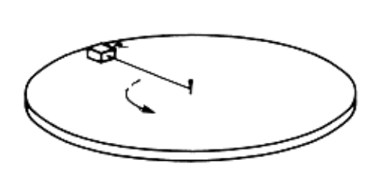

3. A golf ball is struck and its trajectory is sketched below.
[4 marks]

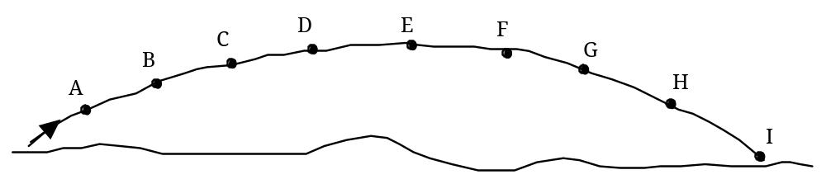

Name the point or points at which:

a) there is no force on the ball.

b) the ball is accelerating down at 9.80 ms⁻².

c) the horizontal velocity is zero.

d) the vertical velocity is zero.

4. The diagram below shows a sumo wrestler in a typical wrestling stance. Explain why a sumo wrestler is so stable.

[4 marks]

5. I An archer fires an arrow at a speed of 33.0 ms⁻¹ at an angle of 25.0° to the horizontal, so that it hits an apple as shown in the diagram below. Using this information and the information provided in the diagram, find the horizontal distance, X covered by the arrow.
[5 marks]
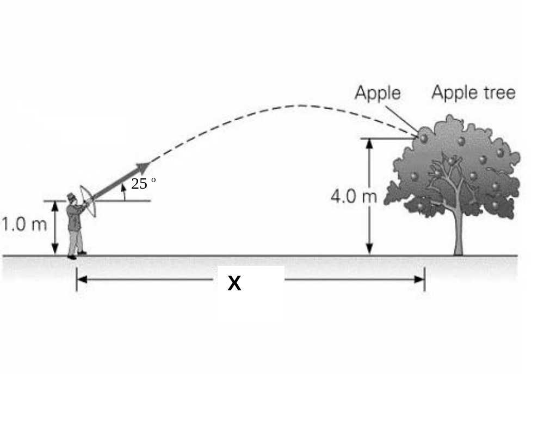

6. During a game of totem tennis a ball of mass 60.0 g swings freely in a horizontal circular path. The string is 1.30 m long and is at an angle of 45.0º to the vertical as shown in the diagram.
[5 marks]
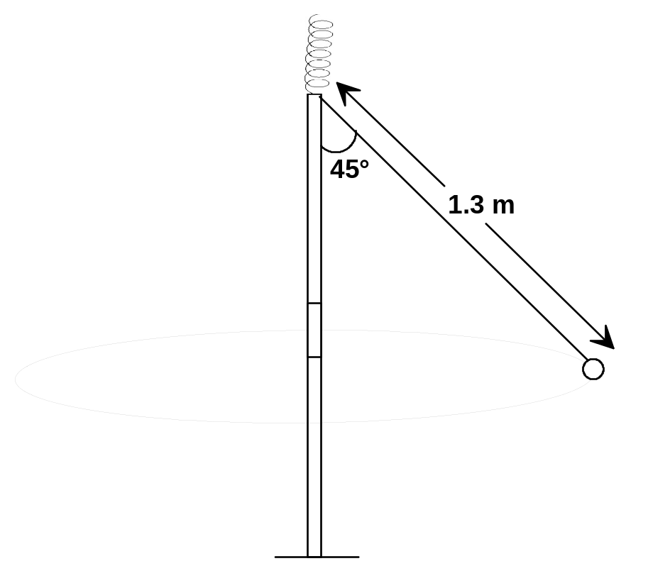

- Calculate the radius of the ball’s circular path.

- Calculate the net force acting on the ball.

7. One day when Marcia was sailing in a yacht she decided to make a few quick calculations. She determined that the mast is a uniform 4.88 m pole of 175 kg. It is supported by the deck and held in position by front and back stays, with a tension in the front stay of 1.00 x 10³ N.
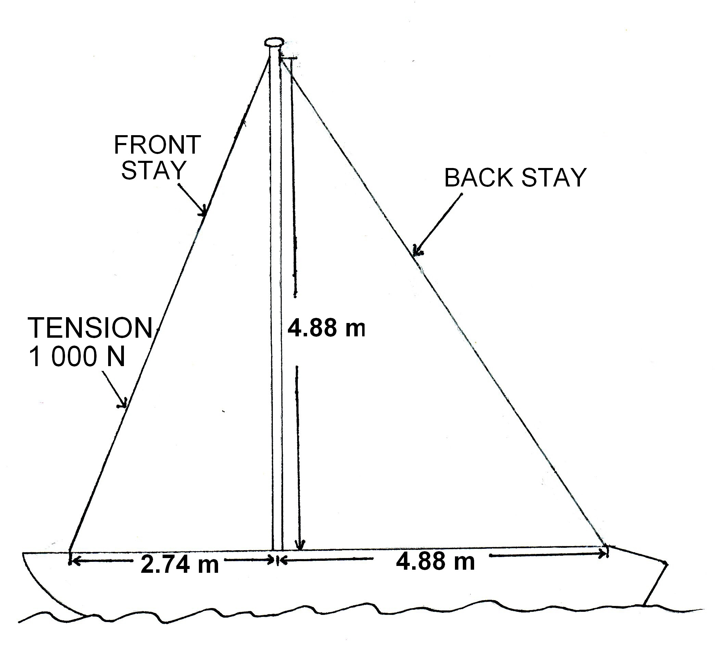

(a) Calculate the tension in the back stay. [4 marks]

(b) Determine the magnitude of the force that the deck exerts on the mast.
[4 marks]

8. In the WACE Physics course we assume that the flux linkage between the primary and secondary windings of a transformer is always 100% efficient. However we recognise that the transformer itself may not be 100% efficient.

- Describe two sources of inefficiency in a transformer.
[2 marks]

- Describe how these inefficiencies affect the electrical characteristics of a transformer.
[1 mark]

- Explain how the design of a transformer can be modified to minimise the effects of these inefficiencies.
[2 marks]

9. A 35.0 mm long wire runs vertically between two magnets where the magnetic field strength is 33.0 mT as shown in the diagram below.
N
S
Current (I)

If the current in the wire is 2.50 A, determine the magnitude and direction of the force acting on the wire.
[4 marks]

10. The diagram below shows a bar magnet being attracted to a simple solenoid connected to a direct current voltage supply (DCV).
[4 marks]

  - Show with an arrow, the direction of current flow through the coil in order for the magnet to be attracted towards the coil as shown below.
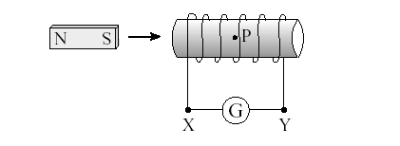
DCVV

  - If you were holding the magnet quite close to the coil and an AC current was applied to the coil, what would you feel? Clearly explain your answer.

11. Oxygen ions (O²⁻) are injected into a vacuum chamber with a uniform magnetic field. For the cross section shown, the magnetic flux is 2.88 10⁻⁴ Wb in an area 30.0 cm by 20.0 cm. The direction of the magnetic field is indicated and the ions enter at a speed of 2.76  10⁴ m s⁻¹.






O²⁻ ions enter moving left
Vacuum chamber

(a) In which direction will the ions be deflected? (Circle the correct response)
[1 mark]
up the page down the page into the page out of the page

(b) Calculate the magnitude of force experienced by each ion.
[3 marks]

12. The simple graphs below could be used to describe a variety of situations. For the situations given, suggest a suitable graph by placing the corresponding letter in the space provided. Note: Not all graphs need to be used, and some may be used more than once.
[4 marks]
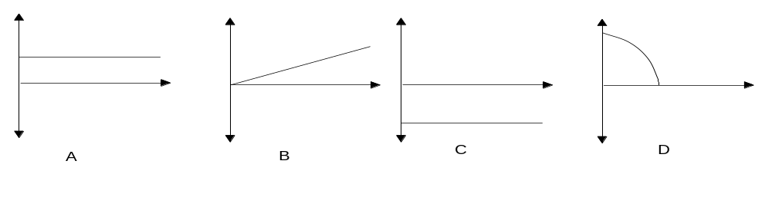
  - The horizontal component of the velocity of a projectile, such as an arrow (ignoring air resistance), plotted against time. ____
  - The vertical component of the velocity of a projectile, such as an arrow (ignoring air resistance), plotted against time. ____
  - The vertical acceleration of a projectile, such as an arrow (ignoring air resistance), plotted against time. ____
  - The magnitude of the net acceleration, of a small mass, being spun in a vertical circle at the end of a length of string with a constant speed, plotted against time. ____

Section B 7 PROBLEM sOLVING questions

Marks allotted: 90 marks out of 180 total (50%)

Attempt ALL 7 questions in this section. Answers are to be written in the spaces provided.

- The orbit of Venus lies between the Earth’s orbit and the Sun. The radius of the planet Venus is 6.05 10⁶ m. The Magellan spacecraft was launched by NASA in 1995 for the purpose of radar mapping Venus. At one stage Magellan was put into a circular orbit of Venus at an altitude of 346 km. It took Magellan 94 minutes to complete this orbit. Magellan had a mass of 1035 kg.

- Calculate the centripetal acceleration of the Magellan satellite in this orbit.
[3 marks]

- Calculate the mass of the planet Venus using the satellite data provided.
[3 marks]

- If the Magellan spacecraft was double the mass in this orbit explain how its orbital period would be affected.
[2 marks]

- There is a location between the Earth and the Sun where the net gravitational field strength due to the Earth and the Sun is zero. Calculate the distance from Earth to this location.
[5 marks]

2. A helicopter is required to drop emergency equipment to a group of outdoor education walkers stranded in rugged bushland. A package is released from the helicopter at altitude (h) directly above the group. The helicopter is moving with a velocity of 8.00 km h⁻¹ at an angle of 40.0º above the horizontal when the package is released. The package lands on the ground 2.50 s after being released.
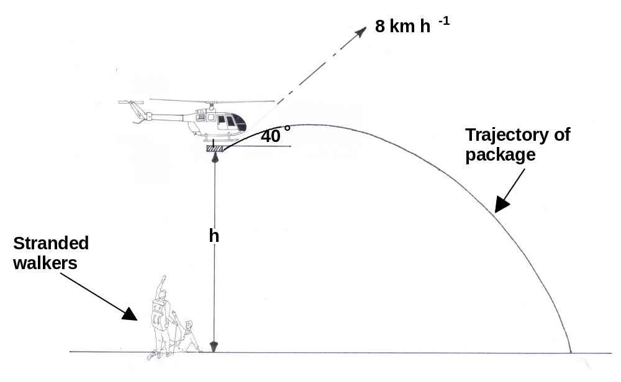
  - Calculate the value of h. [4 marks]

  - If the helicopter continues to fly with its initial velocity, calculate the distance between the helicopter and the package at the instant the package hits the ground. [3 marks]

  - On the grid below draw a graph that best represents the vertical speed of the package as a function of time. Include actual values on the axes. Show three calculations that determine significant points on the graph. [5 marks]

(d) If the helicopter was travelling horizontally at the same speed (8 km h⁻¹) and height (h) when it released the package, would you expect the package to land closer or further away from the group? Explain your answer. [2 marks]

3. The figure below represents a DC motor whose coil is initially stationary.

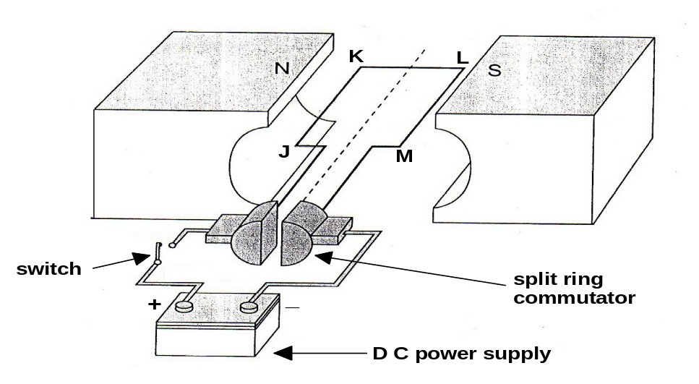

(a) In which direction, clockwise or anticlockwise will the motor rotate when the switch is closed? [1 mark]

(b) Explain your answer to part (a) above. [2 marks]

(c) The above coil has 500 turns and is in a 96.0 mT magnetic field. It is rectangular, with side JK having a length of 65.0 mm and side KL 45.0 mm. Calculate the force on each side JK and KL of the coil when a current of 0.250 A is passing through it.
[4 marks]

The figure below represents an alternator consisting of a rectangular coil with 1200 turns and sides of 0.15 m x 0.20 m, rotating in a uniform magnetic field. The magnetic flux through the coil in the vertical position shown is 2.5 x 10⁻⁴ Wb.
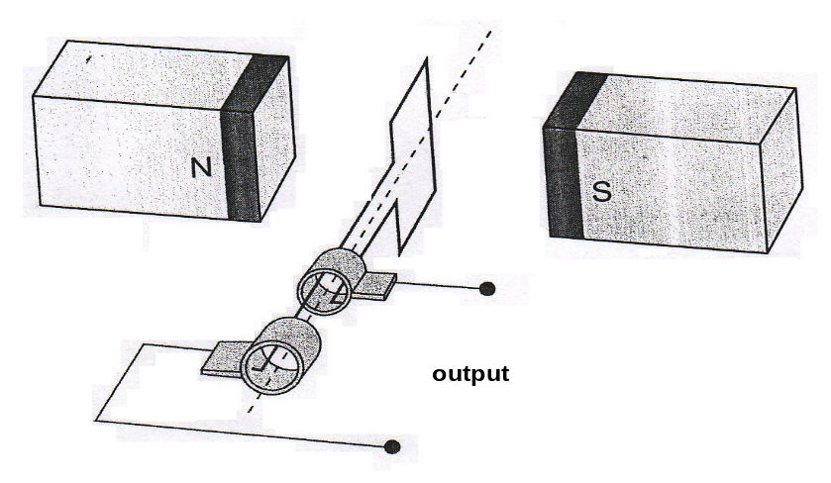
(d) Calculate the magnitude of the magnetic field strength. [2 marks]

(e) If the coil rotates half a revolution from its starting position in 0.03 s, calculate the magnitude of the average induced emf in the coil in this time. [3 marks]

(f) List two changes which would increase the magnitude of the emf? [2 marks]

4. One of the rides at a theme park is a roller coaster that has small cars of mass 414 kg each. One particular car holds three people with a combined mass of 216 kg. A part of the track has a loop of uniform radius 4.00 m, which then leads into a sharp left-hand turn. This turn is banked and has a radius of 12.0 m.

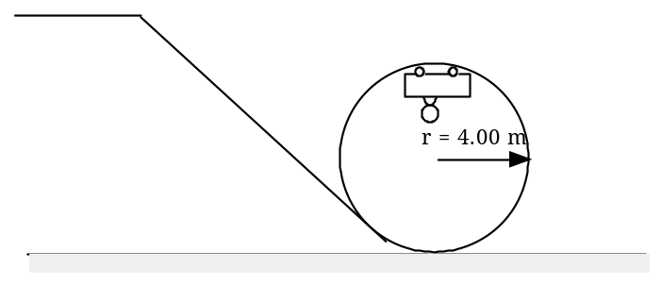
E_{total} = 6.42 x 10⁴ J
(a) The total energy of the car at the top of the loop is 6.42 x 10⁴ J. This is great enough to ensure that the car makes it safely through the loop. Calculate the speed of the car through the top of the loop. [4 marks]

(b) Determine the force exerted by the track onto the car when at the top of the loop. (If you could not calculate an answer to part (a), use v = 6.50 ms⁻¹.) [4 marks]

(c) What is the speed of the car at the bottom of the loop before it enters the turn?
[3 marks]

(d) Calculate the minimum angle of the banking on the turn required to hold the car on the curve. [3 marks]

5. For a new Backpackers Hostel, electric power is transmitted at 66.0 kV AC to a substation transformer where it is converted to 11.0 kV AC for distribution to a pole transformer. It is then delivered to the hostel at 240 V AC.
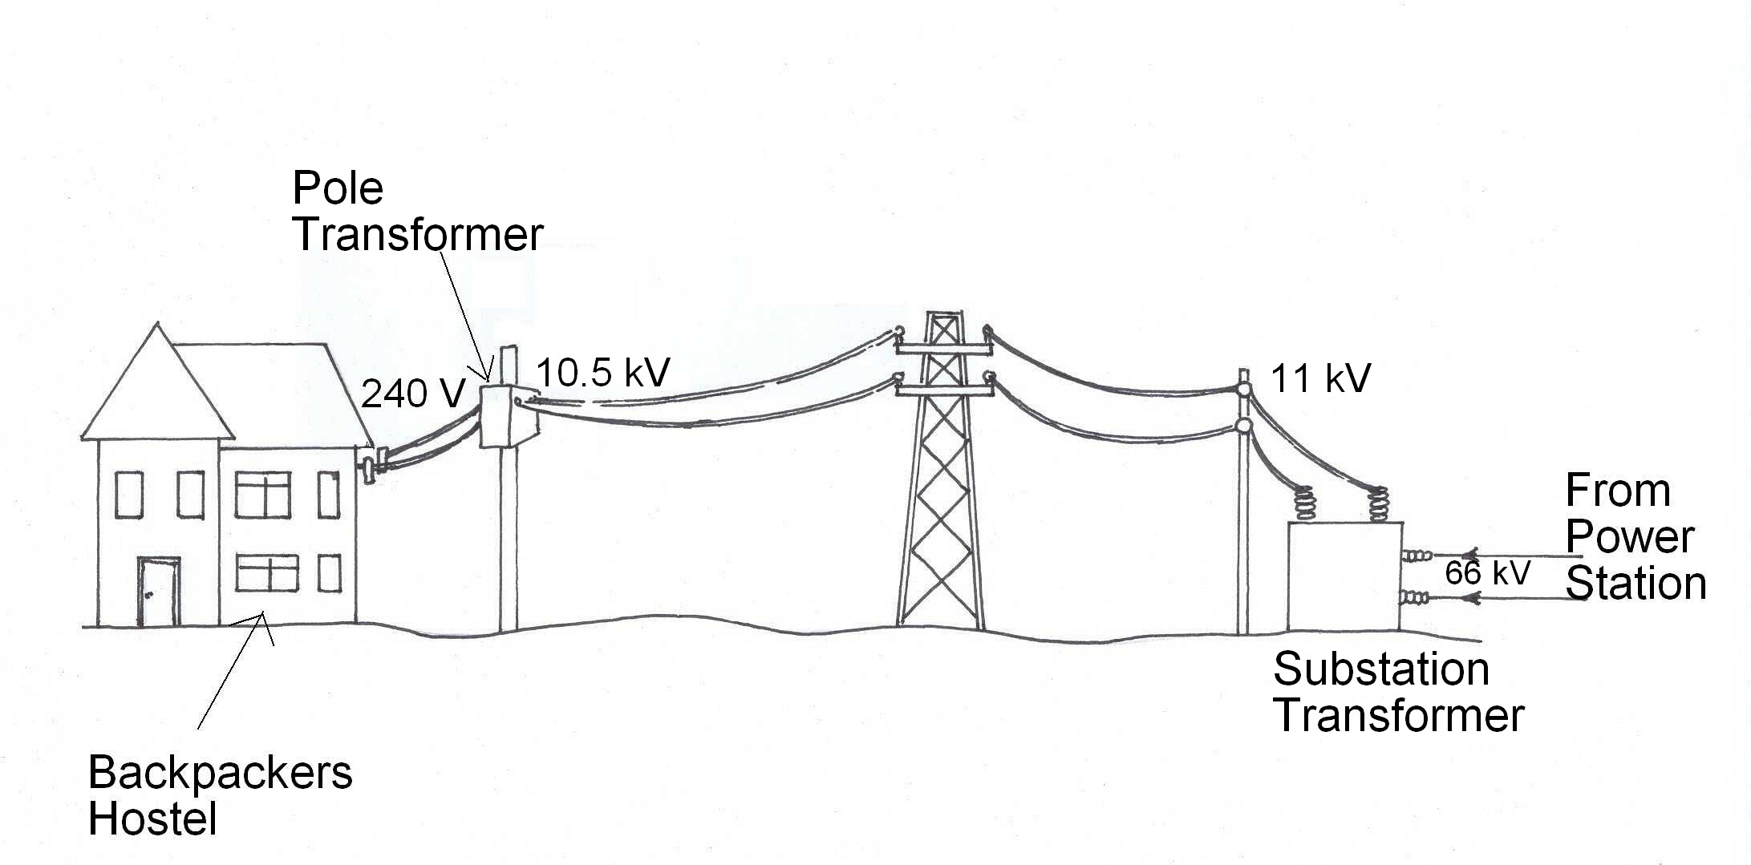

Energy is delivered at a rate of 50.0 kW at the secondary coil of the substation transformer, where the voltage is 11.0 kV AC.

(a) What average current is flowing in the secondary coil of the substation transformer?
[2 marks]

(b) When energy is being delivered at 50.0 kW at the secondary coil of the substation transformer, the voltage at the primary coil of the pole transformers is 10.5 kV. What is the power loss in the wires joining the substation transformer and street pole transformer? [2 marks]

(c) If there are 6.30 x 10³ turns in the primary of the pole transformer, how many turns are in the secondary coil? What current flows in the secondary coil? Assume the transformer is ideal. [3 marks]

(d) Explain why the voltage is transmitted to the hostel at 11.0 kV AC, instead of DC.
[2 marks]

(e) At some times during the day the demand for electricity at the hostel decreases. The output voltage of the substation remains at 11.0 kV. Discuss whether the voltage at the primary coil of the pole transformer will change from 10.5 kV. If it changes, describe whether it gets bigger or smaller, and explain why this occurs. [3 marks]

(f) Explain why electricity is transmitted at high voltages between power stations and the cities where it is used. [2 marks]

6. A see-saw is made by taking a uniform wooden plank of mass 20.0 kg and pivoting it over a steel bar in the middle. The plank is 4.20 m long. A 20.0 kg child sits at one end, A, while a 30.0 kg child sits at the other end, B.

A
B

(a) Calculate the distance from the pivot where a small child of mass 12.0 kg would have to sit in order for the see-saw to balance horizontally?
[5 marks]

(b) Determine the reaction force exerted by the pivot when all three children are on the see-saw at the same time.
[3 marks]

(c) If the small child insists on sitting with the heavier child of 30.0 kg, where would their parents have to pivot the plank in order to have it balance horizontally?
(Give the distance as a measurement from end A.)
[6 marks]

7. An uncharged flake of metal is stripped of 9.57 million electrons and fed into the space between two horizontal plates set 35.0 mm apart. The plates are charged by a source of emf that establishes an electric field strength of 6.40  10⁴ N C⁻¹ in the space. The metal flake is seen to rise up in the space between the plates.

Metal flake
Source of emf
Charged plate
Charged plate
35 mm

- Indicate on the diagram the polarity of the source of emf, the charge polarity on each plate and sketch at least five field lines for the uniform electric field.
[2 marks]

- Calculate the magnitude of the potential difference across the parallel plates.
[2 marks]

- Calculate the magnitude of the electric force acting on the metal flake.
[3 marks]

Section C 2 comprehension/interpretation questions

Marks allotted: 36 marks out of 180 total (20%)

BOTH questions should be attempted. Read each article carefully and answer all the questions with reference to the articles. Candidates are reminded of the need for clear and concise interpretation of the answers. Diagrams (sketches) and equations and/or numerical results should be included if they are appropriate. HINT: It is useful to read through the questions before reading the article.

1 IN SEARCH OF PLANET X

Recently Pluto has lost its status as a planet, after a much anticipated debate over the inclusion of other possible objects as planets in our Solar System. The article below describes the search for these objects.

Marc Buie, eminent astronomer, has been studying the solar system beyond Pluto, among the swarm of small worlds called the Kuiper Belt. He has been looking at the very edge, about 50 times further out from the Sun than the Earth's orbit. Here, at the “Kuiper Cliff”, the number of astronomical objects drops off dramatically. He speaks of the possibility that some “massive object” has swept the zone clean of debris. (para. 1)

Other astronomers agree that there could be another large planet out there. Just how large has become clearer when computer models of the orbits of nearby objects predicted the kind of celestial object that could carve out the Kuiper Cliff and concluded that a planet about the mass of Mars or Earth would provide “a remarkable match” with the observations. (para. 2)

The last time the idea of a tenth planet created a stir was in 1983, when planetary scientists began to realise that some comets were coming from a region not far beyond Neptune and Pluto. Since 2001, astronomers have discovered four KBOs (Kuiper Belt Objects) bigger than 1 000 kilometres across. Caltech astronomers announced the latest one, fully half the size of Pluto, in October 2001. They have provisionally called it Quaoar, after a native god of the indigenous dwellers of the Los Angeles region. Quaoar is over 1 200 kilometres across and orbits the Sun every 288 years. (para. 3)

As well as containing the key to the origin of life, the Kuiper Belt, and Pluto in particular, may hold the key to how planets form. Studying the craters on both Pluto and its moon Charon, for example, will reveal how KBOs have collided over billions of years and provide clues to the way all the planets formed from smaller objects. (para. 4)

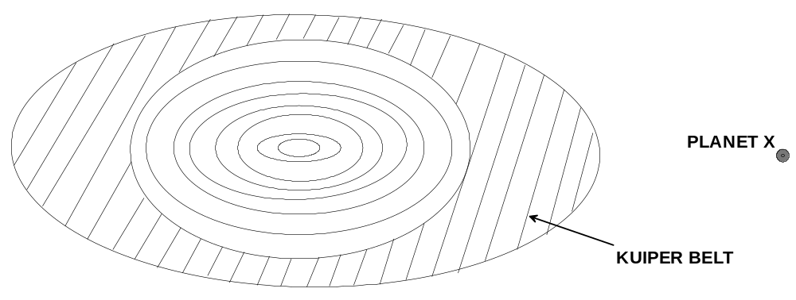

Pluto is only 2320 kilometres across, one-fifth the size of Earth. And the 1978 discovery that it is circled by a moon, Charon, whose diameter is 1270 kilometres, makes it even more distinct from the other planets we know about. Pluto and Charon make up a ‘twin planet’ - the only example in the Solar System. (para. 5)

In 2000, NASA scrapped its own Pluto-Kuiper Express mission on the grounds of expense. Under intense public pressure, it held a competition for universities and industry to design a cheaper, better mission. From this was born the New Horizons space probe (launched in January 2006). The mission's lead scientist calculates that New Horizons will return 10 times more data than the cancelled Pluto-Kuiper Express, and at little more than half the cost. (para. 6)

Just over a year after the New Horizons’ launch, it swung past Jupiter and picked up enough velocity to reach Pluto, possibly as early as July 2015. Indeed, by the time New Horizons reaches the Kuiper Belt, we may have confirmed that a new planet exists. Because of its vast distance from Earth, the only way we’ll find out for sure is to visit this new frontier of the Solar System and get a closer look. (para. 7)

QUESTIONS:

1. Calculate the radius of the orbit of Quaoar about the Sun.
[4 marks]

2. If it is assumed that Quaoar is rocky and has the same density as the Earth, compare the mass of Quaoar with that of the Earth. [density = mass / volume and V_{sphere} = 4/3 π r³]
[4 marks]

3. How is it possible that some “massive object” can sweep the zone clean of debris?
[3 marks]

4. a) What property of Jupiter makes it ideal to use in the ‘sling-shot’ effect?
[2 marks]

b) The Voyager 1 spacecraft, which also used the ‘sling-shot’ effect in 1979 when it travelled past Jupiter with its engines off, is shown in the following diagram.

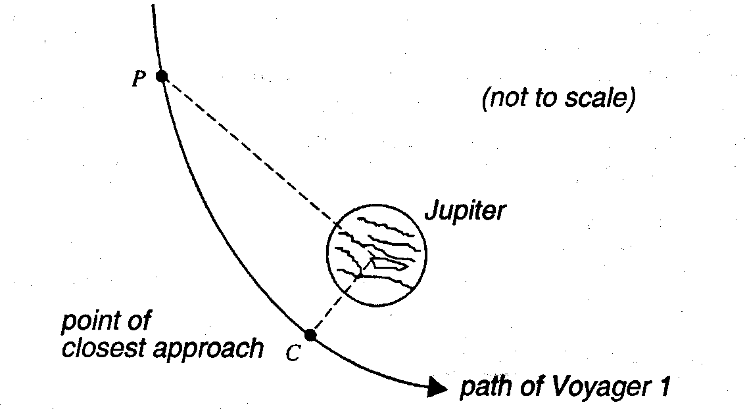

As Voyager 1 moved from point P to point C, the kinetic energy changed by 4.0 x 10¹¹ J. At point C, the point of closest approach, the force attracting the spacecraft to Jupiter was 6.4 x 10³ N. The graph below shows how the force that attracted Voyager 1 depended on the distance from the centre of Jupiter.
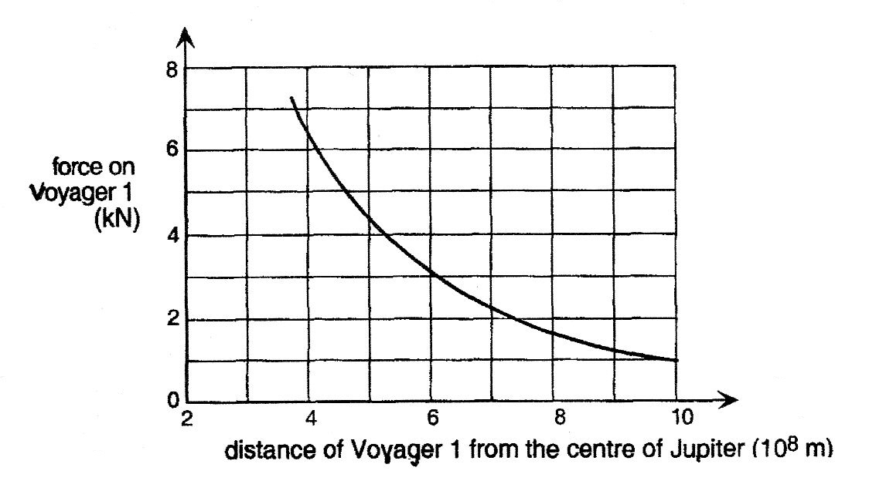
Explain how you would use the information above to determine the distance of point P from the centre of Jupiter. (No calculation is required.) [3 marks]

2 THREE TYPES OF INDUCTION

The following articles explain three types of induction. (A) Mutual induction (B) Self induction and (C) Electromagnetic induction.

A Mutual induction

If two coils are placed near each other as shown in figure 1, a changing current in coil A will induce an emf in coil B. According to Michael Faraday the emf is proportional to the rate of change of flux passing through or linked with it and, since the flux is proportional to the current in coil A, the emf must be proportional to the rate of change of current in coil A.

i.e. emf is α  ΔI / Δt and emf = -M ΔI / Δt

The minus sign is due to Lenz’s law and M is called the mutual inductance of the two coils. It is sometimes said that Lenz’s law is a result of the law of conservation of energy, since energy cannot be created. (para. 1)
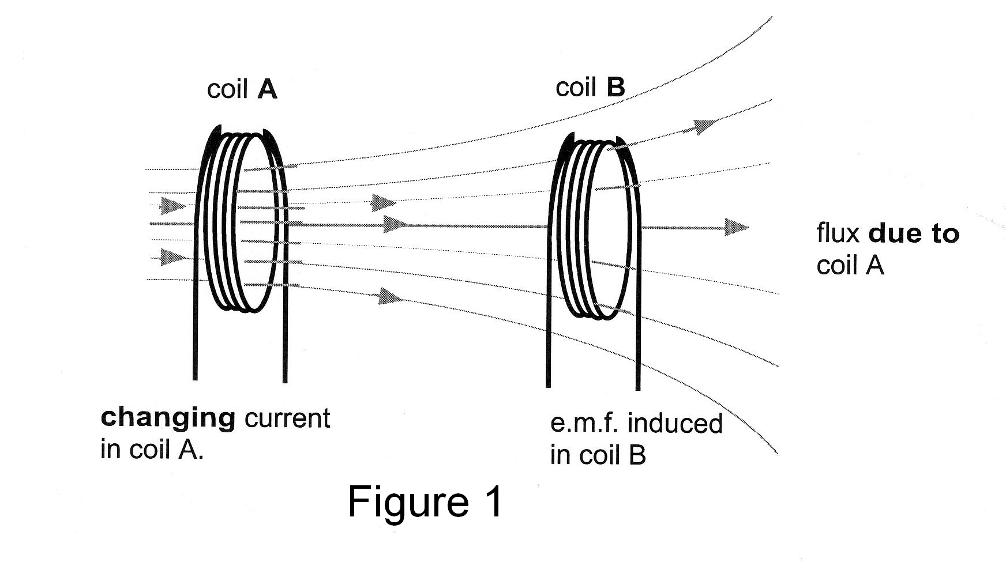

The magnitude of the induced emf in coil B depends on the size and separation of the coils and also on the number of turns in (i) coil A, which produces the flux, and (ii) coil B, the turns of which are in series. The presence of an iron core through both coils effects on the size of the induced emf Mutual inductance is made use of in pacemakers, which are used to control the flow of blood in the heart. Power in an external coil is transmitted via mutual inductance to a second coil in the pacemaker near the heart. (para. 2)

B Self induction

The concept of inductance also applies to an isolated single coil. When the current passing through a coil or solenoid changes, the flux associated with it also changes, and this induces an emf in itself. This emf opposes the changes to the flux and hence the current and the effect is to resist the changes in an alternating circuit. Lenz’s law states that any induced emf will always oppose the changes that are causing it. This means that the current does not rise and fall as much and the peak value will be less. Thus self induction has the same effect on an alternating current as resistance in a direct current circuit. It is self induction that limits the current in the primary of a transformer, which has very low electrical resistance to reduce energy wastage. If a direct current source is connected to a transformer the primary almost always melts. (para. 3)
C Electromagnetic Induction

Many microphones work on the principle of induction. In one form, a microphone is just the inverse of a loudspeaker where a small coil, connected to a diaphragm, is suspended close to a permanent magnet. The coil, which is very light, moves in the uniform magnetic field when the sound waves strike the membrane and the frequency and waveform of the emf induced will be caused by the sound wave that moves the diaphragm. (figure 2). (para. 4)
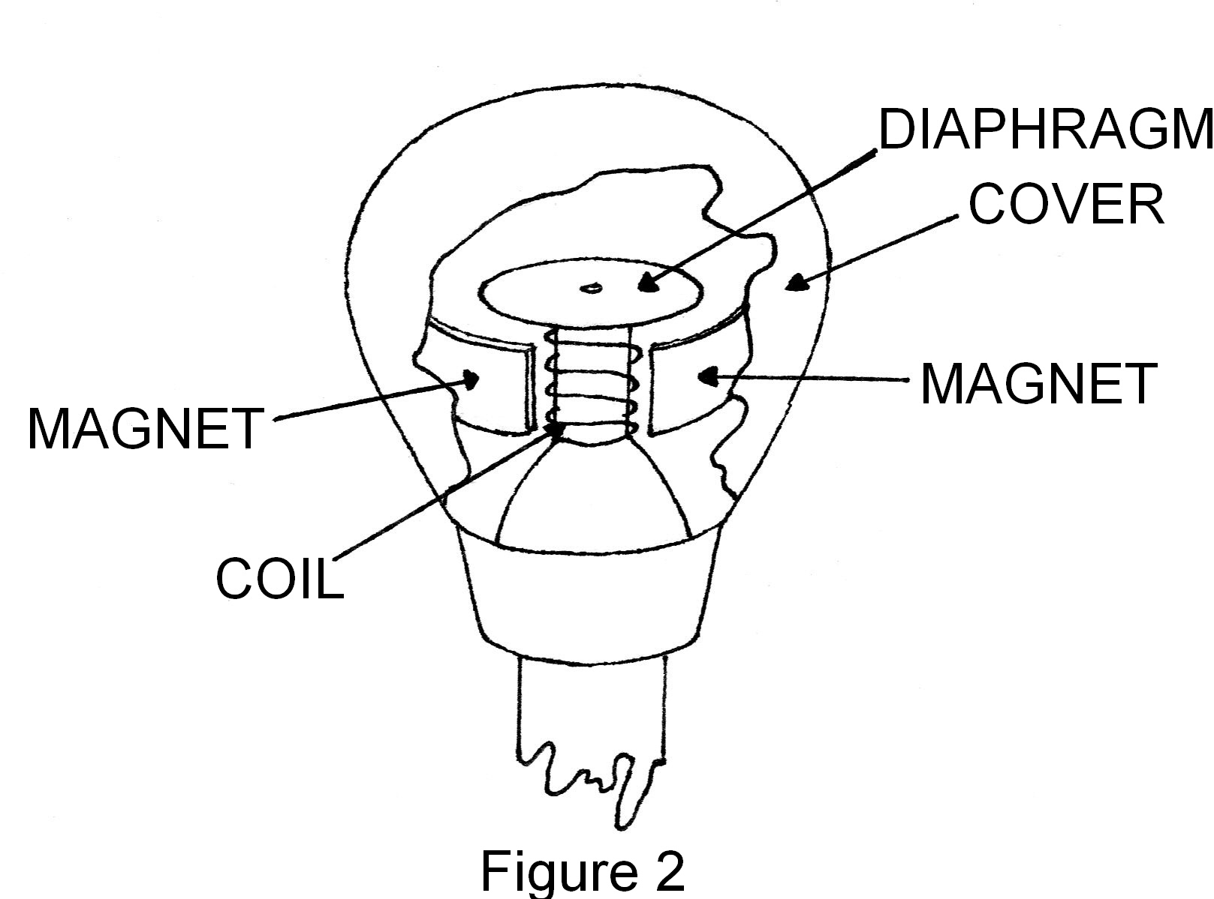

In a ribbon microphone a thin metal ribbon is suspended between the poles of a magnet and this vibrates in response to sound waves. The emf is proportional to the velocity of the ribbon or coil.
(para. 5)

Electromagnetic induction is also made use of in the study of the earth’s crust. A device called a seismograph is used by geophysicists to monitor movements in the earth’s crust. A seismograph is placed in direct contact with the earth and converts the motion of the earth - whether due to an earthquake or an explosion - into an electrical signal. (para. 6)

A seismograph contains a magnet and a coil of wire. The coil is fixed rigidly to the case, which moves as the earth moves. The magnet is suspended from the case. In the type shown (see figure 3) the coil moves with the earth and the heavy magnet, which is suspended by springs that are not very stiff, remains stationary. (para. 7)
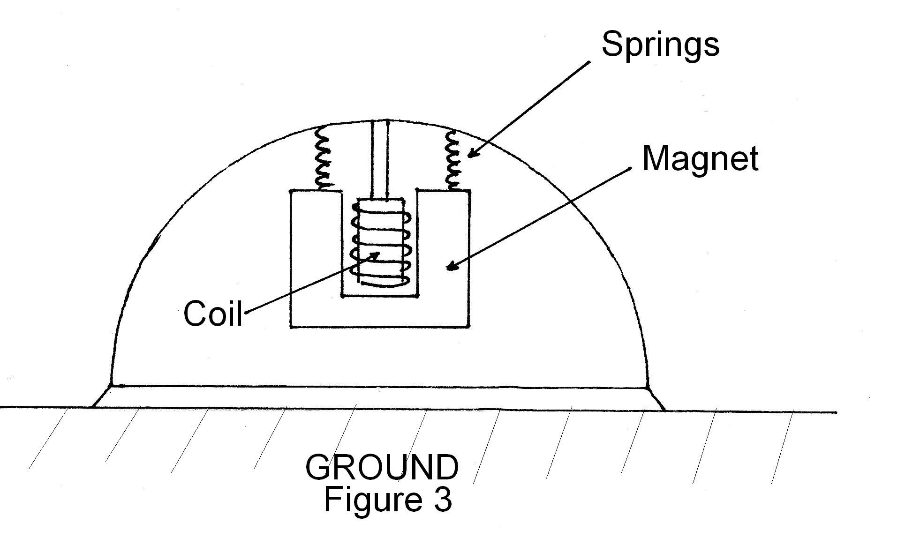

QUESTIONS

1 If in Figure 1, the flux through coil B, which has 1500 turns, is 3.4 x 10⁻² Wb and this is reduced to 4.0 x 10⁻³ weber in 0.125 s, what is the magnitude of the induced emf in coil B? [3 marks]

2 Why does the number of turns in both of the coils affect the magnitude of the emf in coil B? [2 marks]

3 If there was a complete circuit, would the current in coil B be anticlockwise or clockwise, when viewed from the right. [1 mark]

4 What is one advantage of the inductive pacemaker over a battery powered pacemaker? [1 mark]

5 The emf in a ribbon microphone is proportional to the velocity of the ribbon. What ‘principle’ does this involve and explain the connection? [3 marks]

6 Why must the magnetic field be uniform in the microphone? [2 marks]

7 Why is it important that a large magnet, suspended on lightweight flexible springs, is used in the seismograph? [3 marks]

8 Would a transformer make use of mutual or electromagnetic or self inductance for its operation? Explain your answer. [2 marks]

9 Why does a transformer coil melt if it is connected to a DC source? [3 marks]

END OF EXAMINATION
THIS PAGE HAS BEEN LEFT BLANK DELIBERATELY.

THIS PAGE HAS BEEN LEFT BLANK DELIBERATELY.

